Assignment 5: Report

Venkata Bapanapalli

K = 2 K = 5

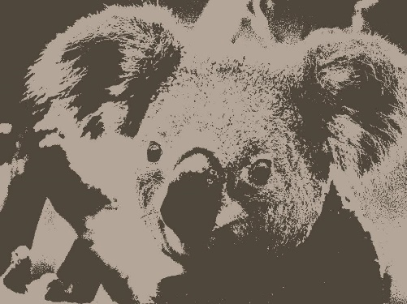

K = 10 K = 15

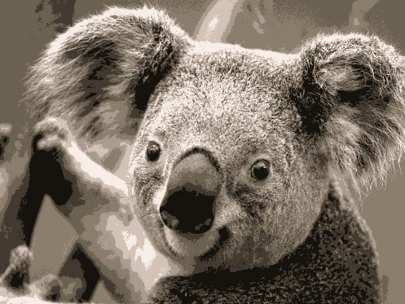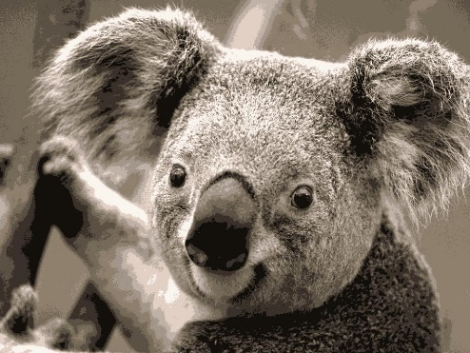

K = 20 Original

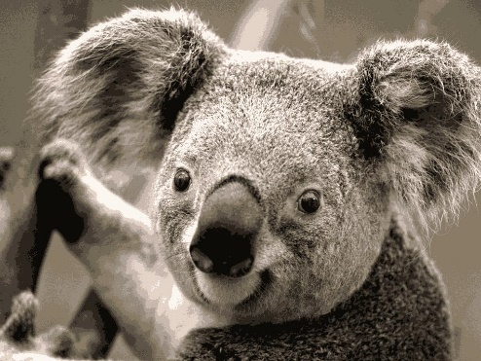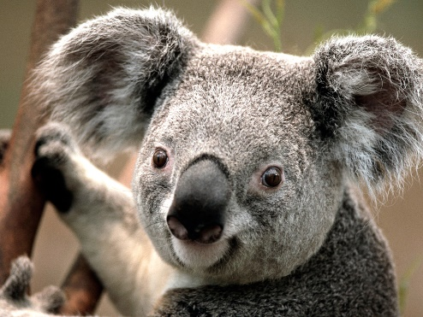

K = 2 K = 5

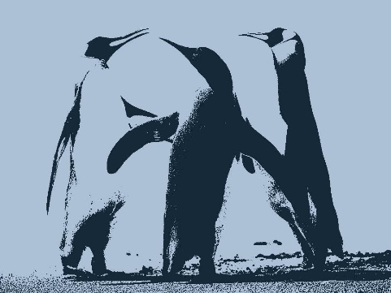

K = 10 K = 15

K = 20 Original

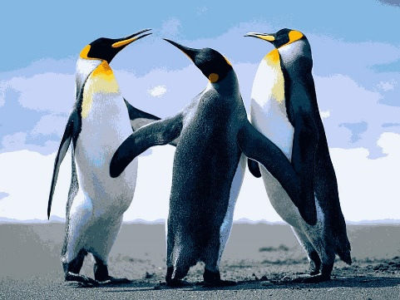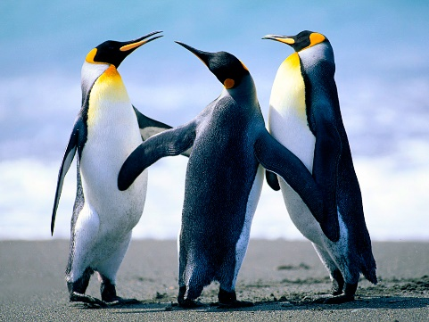

There is a tradeoff between image quality and degree of compression. As we can see, the lower values of k yield images with a huge lack of detail, while higher values of k yield images with much higher detail but also results in larger file sizes. Low values of k means that the number of clusters is lower, while higher values of k equal higher number of clusters. A K value of 15 seems to be the most ideal for koala and a value of 10 seems to be the most ideal for penguins.